Announcement of Shortening of
the Minimum Residence Requirement

<Spring Semester, 2019 / Student Affairs Team>

1. What Does “Minimum Residence Requirement” means?
• Minimum Residence Requirement
: Refers to the minimum term required to complete a course of study.
- Masters Program : 2 years(4 semesters)
- Doctoral Program : 2 years(4 semesters)
- Integrated Program : 4 years(8 semesters)
• Students who have satisfied the minimum credit requirements before the expected period may shorten the minimum residence requirement by no longer than six months for the doctoral program and one year for the integrated program.
[Reference] ARTICLE 35(TIME LIMIT)
Students who have satisfied the minimum credit requirements before the expected period may shorten the minimum residence requirement by no longer than six months for the doctoral program and one year for the integrated program.

2. Application Requirements and Procedure to Shorten Minimum Residence Requirement
• Application Requirements
Master’s  &  Doctoral  Program | For students in which the Spring Semester of 2019 is their 3rd semester of enrollment, and completing the minimum credit requirement or more, with a GPA of B° (3.0/4.5) or higher
Integrated  Program | For students in which the Spring Semester of 2019 is their 6th or 7th semester of enrollment, and completing the minimum credit requirement or more, with a GPA of B° (3.0/4.5) or higher

• Application Procedures
- Student(Apply)

① Management of Registration status →
② Application for shorten the term of study →
③ Search → ④ Addition → ⑤ Write the reasons for application →
⑥ Apply
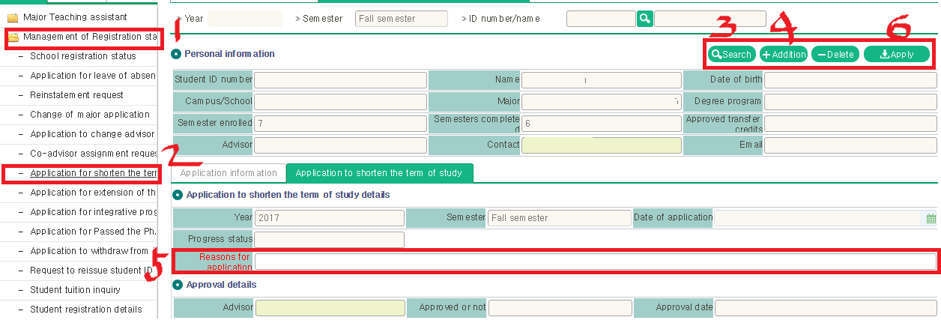

- Advisor(Approve)
① 학적관리 메뉴 → ② 수업연한단축신청승인 → ③ 조회 클릭 →
④ 신청학생 정보 확인 및 체크박스 체크 → ⑤ 승인 클릭
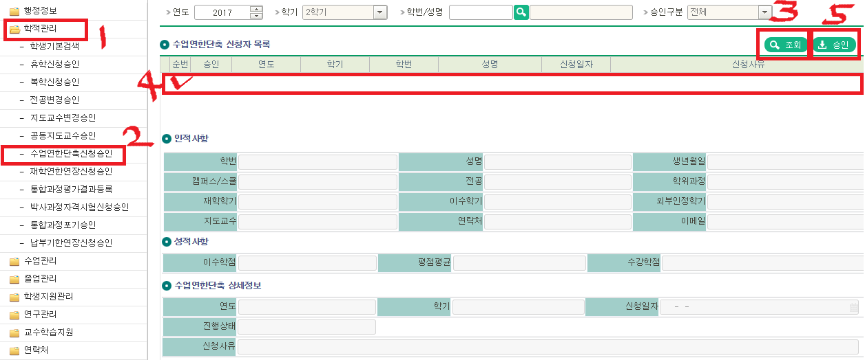
□ Application and approval
ㅇ Period : June 3rd, 2019 ~ July 5th, 2019
- Be punctual

3. Note
• Even if there is an application to shorten their Minimum Residence Requirement, the application may be rejected depending on application requirements.
• If the requirements have not been satisfied, the students must enroll and take classes just like their peers for the remaining semesters.
• The application will become invalid if the students is unable to receive confirmation from their advising professor before the application deadline.

[Attachment] Course Completion Requirements

Common requirement
At least 2 credits should be acquired from lab rotation or internship

<Students who entered after Fall semester, 2012>
Credit classification |  | Grading system | Required number of credits
 |  |  | Master's | Ph.D. | Integrated
Course  credit | General  course | Percentage or (S/U) | 3 credits | 3 credits | 6 credits
 | Major  course | Percentage | 12 credits | 12 credits | 24 credits
Research  credit | On-site  research | Percentage | 12 credits | 12 credits | 24 credits
 | Seminar | (S/U) | 2 credits | 2 credits | 4 credits
Thesis Guidance |  | (S/U) | 3 credits | 3 credits | 6 credits
Total number of credits |  |  | 32 credits | 32 credits | 64 credits

<Students who entered after Fall semester, 2016>
Credit classification |  | Grading system | Required number of credits
 |  |  | Master's | Ph.D. | Integrated
Course  credit | General  course | Percentage or (S/U) | 3 credits | 3 credits | 3 credits
 | Major  course | Percentage | 12 credits | 12 credits | 24 credits
Research  credit | On-site  research | Percentage | 12 credits | 12 credits | 24 credits
 | Seminar | (S/U) | 2 credits | 2 credits | 4 credits
Thesis Guidance |  | (S/U) | 3 credits | 3 credits | 3credits
Total number of credits |  |  | 32 credits | 32 credits | 58 credits

