Application 2019 Open UST with USTians

▣ Information on Your Visit
Purpose of Visit
Number of Visitors
Most Desired  Date & Time | Choose a date between Aug. 12 (Mon.) - Sep. 19 (Thu.), 2019, business days only
2nd Most Desired Date & Time | Choose a date between Aug. 12 (Mon.) - Sep. 19 (Thu.), 2019, business days only

 | Visitor1 | Visitor2 | Visitor3 | Visitor4 | Visitor5
Full Name
Gender | (Male) / (Female)
University
Major
Academic  Program | (Undergraduate) / (Master’s)
Grade | (1st) / (2nd) / (3rd) / (4th)
School Register | (Enrolled) / (Leave of Absence) / (Completed) / (Graduated)
Nationality
Mobile Number
E-mail Address
UST Newsletter  E-mails | (receive) / (refuse)
Signature
▣ Information on Visitors

* This application should contain every visitor’s information. Please add the table cells in case of necessity.
* By submitting your applications, you are agreeing to that the personal information you provided will be retained and used in accordance with the relevant regulation of UST. Collected personal information will be used to operate this program.
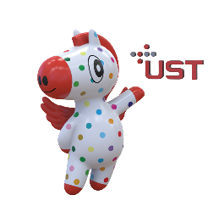
* You will receive an email confirmation in two business days after you submit your application to pje@ust.ac.kr.

We hereby certify that the above information is all true and correct.

MM / DD / 2019
▣ Identification cards

Visitor1
Visitor2
Visitor3
Visitor4
Visitor5

