Comprehensive Exam for 2021 Spring Semester

□ Qualification for Applying Comprehensive Exam
ㅇ Students who have acquired or is expected to acquire the credits
Type | M.S. and Ph.D. program | Integrative program
who entered before  fall semester, 2012 | More than Course credit 14  & Research credit 15 | More than Course credit 28  & Research credit 30
who entered from  fall semester, 2012 | More than Course credit 15  & Research credit 14 | More than Course credit 30  & Research credit 28
who entered from  fall semester, 2016 | More than Course credit 15  & Research credit 14 | More than Course credit 27  & Research credit 28
who entered from  spring semester, 2019 | More than Course credit 18  & Research credit 14 | More than Course credit 32  & Research credit 28
․ Course Credit : Common Course and Major Course, ․ Research credit : Field Research and Seminar

□ The Role and Organization of Comprehensive Examination Committee

Type | Ph.D. & Integrative program | M.S. program
Role | - Make a plan for exam type, question, schedule and Manage  - Assess the Comprehensive Examination
Organization | At least 5 to 7 persons  (Advisor should be included) | At least 3 to 5 persons  (Advisor should be included)
- The members of the committee can be :
either all In-house Members or In-house Members + Outside Members
- Outside Member: A specialist who has Ph.D. degree at the related field
(Proof of employment needed)
- The majority of members must be UST professor
Chairperson | Picked from committee members.(Advisor cannot be a chairperson.)
․ In-house Member : A full-time professor or affiliated professor who has a status of UST professor
․ Outside Member: A specialist who has Ph.D. degree at the related field
(Proof of employment and Consent Form for Collection/Use/Provision of Personal Information [attachment 3] needed)

□ Schedule & Process
ㅇ Schedule : March 2nd ~ April 9th
ㅇ Process (All the students)
① Formation of  Comprehensive  Exam Committee | ▶ | ② Request for  Comprehensive Exam | ▶ | ③ Taking the Exam
Advisor  Arrange the committee members |  | Student  Upload “Graduation Plan’[attachment 1] for request |  | Student  Written Test or Oral Test  &  Upload Exam paper and Answer sheet
 |  |  |  | ▼
⑥ Submission of  Documents | ◀ | ⑤ Check the documents | ◀ | ④ Assessment
Submit All documents to the campus coordinator |  | Student  Check the documents to upload  Advisor  Check the documents to submit |  | Advisor  Check "Pass" or “Fail”

★ The number of times a student may take the comprehensive exam shall be
restricted to two.
□ Fees for Comprehensive Exam Committee Members(With Tax deduction, Fee is wired.)
Type |  | Amount of Fee  (for Ph.D/M.S./Integrative)
Internal  jury | UST Professor except for advisor | 200,000 KRW
External  jury | Researcher from UST Campus  (Not UST Professor)
Professor or Researcher from institute or Univ.
(except for UST Campus)
 | Professor or Researcher from  Overseas institute or Univ. | 300,000 KRW
- If a lack of required documents, the result won’t be recognized.
□ Documentation
ㅇ Submit all documents related to Comprehensive Exam to the campus coordinator
1. Comprehensive Exam Assessment Report(종합시험 평가결과서)
→ Can be printed out in UST portal system (by advisor only).
2. Comprehensive Exam Evaluation [Attachment 2] (종합시험 평가표)
→ All committee members must fill out the form.
3. Graduation Plan [Attachment 1] (졸업준비계획서)
→ Upload the file when students apply for comprehensive exam.
4. Exam paper and Answer sheet(문제지 및 답안지)
→ Upload the file to UST portal system
5. (Outside Member only) Proof of employment (재직증명서)
→ Upload the file to UST portal system(by advisor only)
6. (Outside Member only) Consent Form for Collection/Use/Provision of Personal
Information [Attachment 3] (개인정보활용동의서)
→ Upload the file to UST portal system(by advisor only)
※ If you don’t know who campus coordinator is, please contact graduation@ust.ac.kr.

→ From 1 to 2 are documents to submit, 3 to 6 are documents to upload.

□ Inquiry
ㅇ KIM HEE GWON, Tel : 042-865-2342, Email : graduation@ust.ac.kr
Reference - Student |  | Comprehensive Exam Application

□ Apply on the portal system
- 1. Click “Search” → Click “Addition” → Click “Apply”
- 2. Check out [the attachment 1 – Graduation Plan] and fill out the form
- 3. Sign you and your advisor's, then scan and click “File upload” to upload it

■ How to do
○ Comprehensive Exam Application

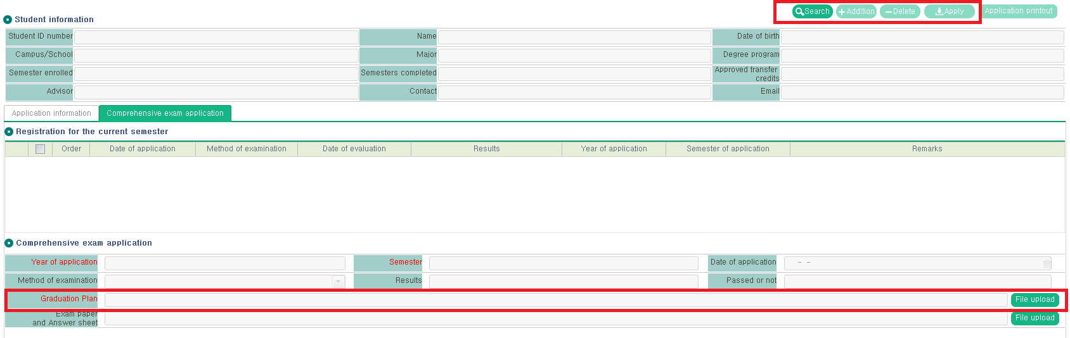
1) Click SEARCH and ADDITION and APPLY
2) You don't have to do anything else. Do not print out application.
3) Check out [the attachment 1] and fill out
4) Scan and UPLOAD it.
※ File upload is mandatory. Can’t process otherwise.

Reference - Student |  | Uploading the exam paper and answer sheet

□ Apply on the portal system
- 1. It’s the same page as the application
- 2. Scan your exam paper and answer sheet (or PPT file for oral presentation)
- 3. click “File upload” to upload it

■ How to do
○ Comprehensive Exam Application

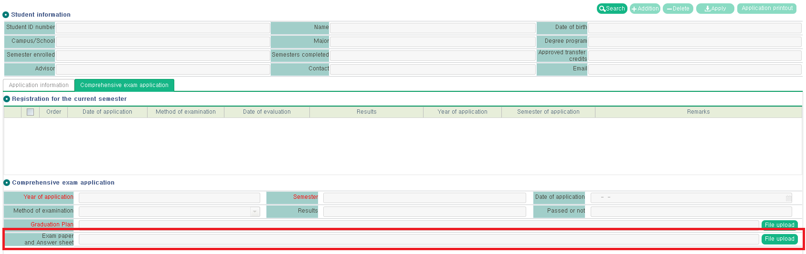
1) Scan and UPLOAD it.
※ File upload is mandatory.
[Attachment 1] Graduation Plan

Graduation Plan

- Personal Information
Name |  | Student ID
Campus |  | Major
Program | M.S/Ph.D./Integrative | Term of admission | Spring/Fall 2○○○

- Preparation for Graduation
- Credit Acquisition Status and Plan
Type | General | Major | Field Research |  | Seminar | Thesis  Writing | Sum
 |  |  | internal | external
Status
Plan
Sum
*each student shall be required to complete at least two credits among the field research of another laboratory or external institution in addition to the field research of his/her advisor.

- Completion of Graduation Requirements
Type |  | Satisfactory of Requirements | Note
Newcomers Orientation |  | Acquired/ Not Acquired
Foreign Language Grade | English | Acquired/ Not Acquired
 | Korean | Acquired/ Not Acquired
Thesis Publication Requirements |  | Acquired/ Not Acquired
Comprehensive Examination |  | Expected to Apply  ( Time : 2○○○ Spring/Fall)
Dissertation Examination |  | Expected to Apply  ( Time : 2○○○ Spring/Fall)
Expected Graduation Time |  | February / August of 2○○○

I submit the graduation preparation plan as above.

YY/MM/DD

NAME : (Sign)
ADVISOR : (Sign)
[Attachment 2] Comprehensive Exam Evaluation

Comprehensive Exam Evaluation
(종합시험 평가표)
▢ Student Information
Name |  | Program | M.S / Ph.D / Inte.
Campus |  | Major
Opinion
Evaluation | Pass / Fail

YY/MM/DD

Committee Member : (Sign)
[Attachment 3] Consent Form for Collection/Use/Provision of Personal Information
When University of Science and Technology(‘UST’) intends to collect and use or provide the personal information to National Tax Service, UST shall obtain my consent pursuant to the Article 15, Article 17, Article 23, Article 24 of 「Act on the Protection of Personal Data」. This Form should be filled out by Comprehensive Exam Committee members.
1. Matter concerning Collection and Use of Personal Information
Purpose of collection and use | ￭ Fee Remittance  ￭ Reporting of Taxes
Items of to be collected and used | ￭ Required personal information  ‣Name :  ‣Social Security No. (or passport No.) :  ‣Address :  ‣Bank Information(Name / Account No. / Swift code) :
Retention and use period | By Completing Fee Remittance & Reporting of Taxes
Whether or  not to Consent  to CollectionUse | If you do not consent to collection and use of personal information, Fee will be not wired.
Agree or Disagree | I hereby agree to collection and use of my personal information by UST. (Agree ☐ Disagree ☐)
2. Matter concerning Provision of Personal Information
Authorized 3rd Parties | ￭ National Tax Service
Purpose of Provision to  the 3rd parties | ￭ Reporting of Taxes
Contents of Personal Information to  be Provided | ￭ Required personal information  ‣Name, Social Security No. Address, Account No. & Bank
Period of Retention and Use by 3rd parties | By Completing Fee Remittance & Reporting of Taxes
Whether or not to Consent to Provision | If you do not consent to collection and use of personal information, Fee will be not wired.
Agree or Disagree | I hereby agree to collection and use of my personal information by UST. (Agree ☐ Disagree ☐)
I have understood the contents of this Consent Form for Collection Use Provision of personal
information and hereby consent to its contents.
Year Month Date

Name : (Signature)

